
Test Case
Laser Tilt Control
Robotic Cognition System for Wheelchair
Unicamp

Table of Contents
1 Purpose of this Document 3
2 Building Blocks 4
3 Interfaces 5
4 Mapping 6

Document Information
Project Name: | Robotic Cognition System for Wheelchairs
Prepared By: | Tarcisio Franco de Carvalho | Document Version No: | 1.0
Title: | Test Cases | Document Version Date: | 24/Jun/20
Reviewed By: |  | Review Date:
Distribution List
From | Date | Phone/Fax/Email

Acronyms
Acronym | Description

Document Version History
Version  Number | Version  Date | Revised By | Description
1.0 | 24/Jun/2020 | Tarcisio Franco | Initial Version

Purpose of this Document
Define and document the test cases related to the robot cognition system solution for wheelchair

Test case A: Laser tilt control

This test case will verify the laser tilt movement capability based on a controller in a web page UI.

Entry criteria
- Gazebo up and running the simple_blocks.world configuration
- Gazebo up and running the sim_model.urdf.xacro related to the wheelchair robot components
- Python web server up and running the web_app.py script

Exit criteria
- Move the laser tilt 15 degrees in the Web UI control having the same visual response in the environment simulation
- Move back laser tilt -30 degrees in the Web UI control having the same visual response in the environment simulation

Test execution and results

- Start Gazebo environment simulation
On the project root folder, run the script ./sim_model/scripts/launch.sh it will process the simple_blocks.world and sim_model.urdf.xacro files

Result
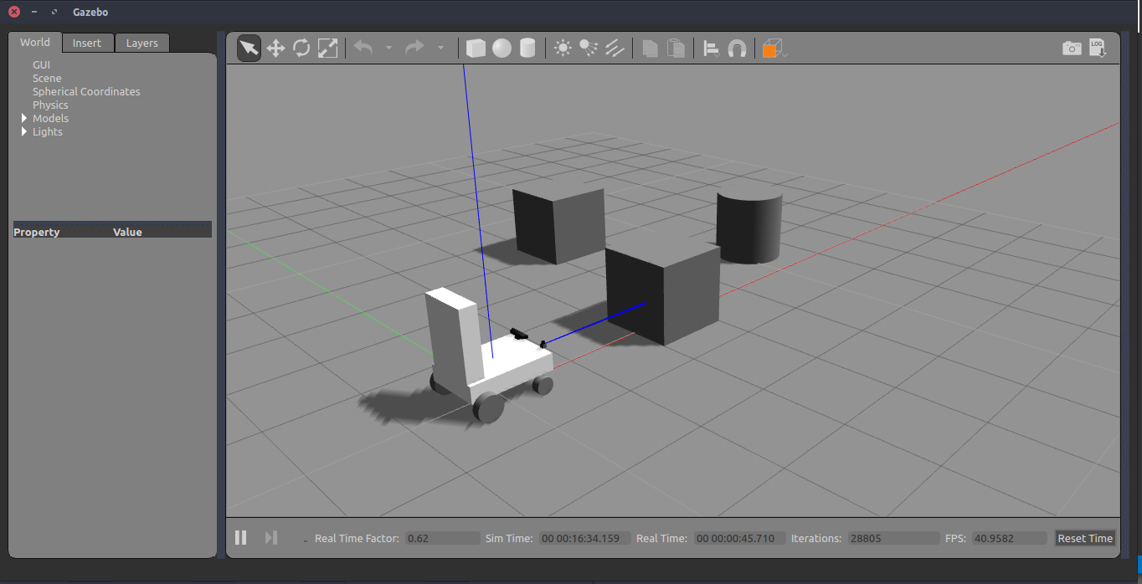

- Start web user interface to control the laser

On the project root folder, run the script python src/web_app.py it will start the flask web server and a web page where the laser can be controlled. After starting, in a web browser open the http://localhost:8080

Result
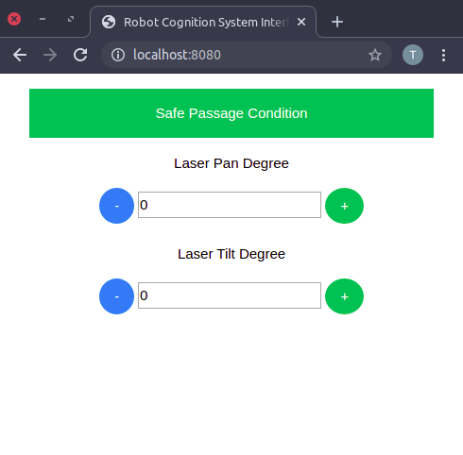

- Move the laser in tilt direction 15 degrees
In the UI, in Laser Tilt Degree control click in the green (+) button until getting 15 degrees. You should see in the Gazebo the laser tilt movement expected

Result
Passed

Before | After
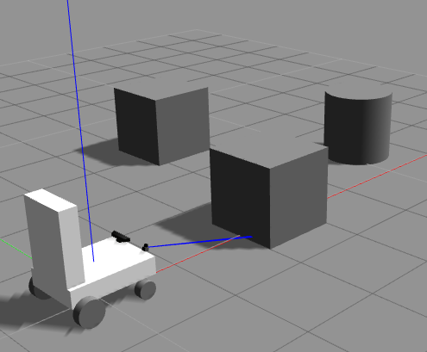
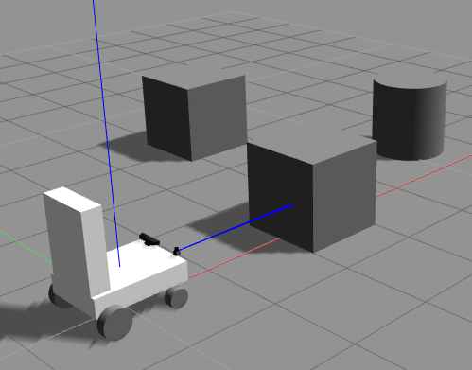

- Move the laser in tilt direction -30 degrees
In the UI, in Laser Tilt Degree control click in the blue (-) button until getting 30 degrees. You should see in the Gazebo the laser tilt movement expected

Result
Passed

Before | After
